Uniform Policy

Policy agreed (date): | July 2024
Policy published (including on website) (date): | July 2024
Next review (date): | July 2025

AIMS OF OUR POLICY

- To provide a clear, fair, inclusive and consistent approach to uniform
- To provide a sense of belonging and identity.
- To support children in being active throughout the day
For the purposes of this policy, “uniform” includes the following elements of pupils’ appearance:
- Clothing
- Footwear
- Hairstyles and headwear.
- Jewellery and other accessories.
- Cosmetics such as nail polish.
This policy lays out the measures the school has taken to ensure a consistent, fair and inclusive uniform policy, and to implement a uniform that reflects the needs of all pupils, is affordable, and provides the best value for money for both the school and pupils’ families.
In writing and updating this policy, we have sought to:
- Consider how this policy might affect groups represented in the school, especially those who share protected characteristics as defined by the Equality Act 2010.
- Take a sensible approach to allow for exceptions to be made, e.g. during adverse weather.
- Ensure that the uniform is suitable and safe for pupils who walk or cycle to school.
- Choose items which are practical, comfortable, appropriate to the activity involved and affordable.
- Ensure the policy is easy to access and understand.

Legal framework
This policy has due regard to all relevant legislation and guidance including, but not limited to, the following:
- Human Rights Act 1998
- Education and Inspections Act 2006
- Equality Act 2010
- Education Act 2011
- The UK General Data Protection Regulation (UK GDPR)
- Data Protection Act 2018
- Education (Guidance about Costs of School Uniforms) Act 2021
- DfE (2021) ‘Cost of school uniforms’
- DfE (2021) ‘School Admissions Code’
- DfE (2024) ‘School uniforms: guidance for schools’
- Equality and Human Rights Commission (2022) ‘Preventing hair discrimination in schools’

Roles and responsibilities
The governing board is responsible for:
- Establishing a practical and smart school uniform that accurately reflects the school’s vision and values.
- Ensuring that the school’s uniform is accessible, inclusive, and does not disadvantage any pupil because of their protected characteristics or socio-economic status.
- Ensuring that the school’s uniform is accessible and affordable.
- Ensuring compliance with the DfE’s ‘Cost of school uniforms’ guidance.
- Processing and approving all eligible School Uniform Assistance Application Forms.
The headteacher is responsible for:
- Enforcing the school’s uniform rules on a day-to-day basis.
- Ensuring that teachers understand this policy and what to do if a pupil is in breach of the policy.
- Listening to the opinions and wishes of the school community in regard to the school’s uniform and making appropriate recommendations to the governing board.
- Providing pupils with an exemption letter as appropriate, e.g. for a pupil who has a broken arm and requires a loose-fitting shirt.
Staff are responsible for:
- Ensuring that pupils dress in accordance with this policy at all times.
- Ensuring that pupils understand why having a consistent and practical school uniform is important, e.g. school identity.
Parents are responsible for:
- Providing their children with the correct school uniform as detailed in this policy.
- Informing the headteacher if their child requires an exemption to the uniform rules for a period of time, with a reason why.
- Ensuring that their child’s uniform is clean, presentable and the correct size.
Pupils are responsible for:
- Wearing the correct uniform at all times, unless the headteacher has granted an exemption.
- Looking after their uniform as appropriate.
- Understanding and respecting why a school uniform is important to the school, e.g. school identity and community.

Cost principles
The school will develop its uniform policy in relation to the following starting principles:
- The school will seek to ensure that the uniform is affordable. In so doing, the school will consider the total cost of school uniforms, taking into account all items of uniform or clothing parents will need to provide while their child is at the school.
- The school will seek to keep the use of branded items to a minimum.
- The school will seek to ensure that uniform supplier arrangements give the highest priority to cost and value for money, including the quality and durability of the garment.
- The school will seek to ensure that second-hand uniforms are available for parents to acquire. Information on second-hand uniforms will be published on the school’s website.
Principles in practice
In accordance with the ‘School Admissions Code’, the headteacher will ensure that the school’s uniform requirements do not discourage parents from applying for a place for their child.
The school will assess the overall cost implications of its uniform policy regularly, including prior to making any changes to the school uniform. When evaluating whether costs are reasonable and proportionate, the school will take into account the opinions and situations of:
- Economically disadvantaged parents.
- Parents with multiple children who are, or will be in the future, pupils at the school.
- Parents of younger children, as they are likely to grow quickly and require new sets of uniform more frequently.
- Parents of pupils with protected characteristics that may impact their ability to access the uniform.
- CLA and CPLA.
The school will evaluate the cost of its uniform based on the overall collection of uniform items that parents would need to purchase for a pupil, rather than on the cost effectiveness of individual items; this will include consideration of the fact that parents will need to purchase multiples of certain items, e.g. shirts and socks, to ensure their child can come to school in clean uniform every day.
The school will keep branded uniform items to a minimal level that is reasonable for all members of the school community. The school defines a branded uniform item as any item of clothing that cannot be purchased at a range of retailers, e.g. supermarkets, due to the item’s logo, colour, design, fabric or other unique element. Where the school requires an item of branded clothing, it will assess how prices can be kept as low as possible and put measures in place to facilitate this. This includes making donated second-hand uniform available for purchase at a lower price.
The school will meet the DfE’s requirements and recommendations on costs and value for money. Care will be taken to ensure that school uniform is affordable for all current and prospective pupils, and that the best value for money is secured through reputable suppliers.
The school will work with multiple suppliers to obtain the best value for money possible. Any savings negotiated will be passed to parents where possible. The school will not enter into exclusive single-supplier contracts or cash-back arrangements.
The school will not make frequent changes to uniform requirements and will take the views of parents and pupils into account when considering any future changes.

Equality principles
The school takes its legal obligation to avoid unlawfully discriminating against any pupil very seriously.
In line with the above, the school will aim to ensure that its uniform policy is as inclusive as possible so that all pupils can access a school uniform which is comfortable, suitable for their needs, and reflects who they are, while avoiding any direct or indirect discrimination on the basis of protected characteristics or socio-economic status.
The school will ensure that parents and pupils are consulted over any changes to school uniform, and that, where appropriate and with pupils’ consent, views and advice are sought specifically from pupils, and parents of pupils, who:
- Are transgender or non-binary.
- Are of a religious or cultural background that has specific dress requirements.
- Have SEND and/or sensory needs.
Parents’ concerns and requests regarding school uniform and amendments to it are handled on a case-by-case basis by the headteacher and governing board, and always in accordance with the school’s Complaints Procedures Policy.
Information on how the school ensures its uniform policy does not discriminate against pupils with specific protected characteristics is outlined below.
Gender
To avoid disproportionately impacting pupils of a certain gender, the school will ensure that the cost of uniform is as equal in price as possible across items for all genders.
This includes:
- Adhering to the procedures laid out in the ‘Cost principles’ section of this policy.
- Not directly requiring pupils of a certain gender to buy additional uniform, e.g. by requiring female pupils to buy both trousers and skirts.
- Not indirectly requiring pupils of a certain gender to buy additional uniform, e.g. by offering football in PE to only male pupils and requiring they buy football boots to participate.
- Not holding pupils of different genders to different uniform standards, e.g. by banning certain hairstyles for only one gender.
Religion and belief
To avoid disproportionately impacting pupils of a certain religion, belief or culture, the school will ensure that there is flexibility to allow pupils to present themselves in a way that adheres to their dress requirements as far as possible, within the school’s uniform policy.
The school will endeavour to meet all requests for amendments to the uniform for these purposes; however, the needs and rights of individual pupils will be weighed against any health and safety concerns appropriate to the circumstances, e.g. if safety headgear needs to be worn.
Race
To avoid disproportionately impacting pupils of a certain race, the school will ensure that its uniform policy does not constitute unlawful indirect discrimination through blanket rules. This includes:
- Not banning hairstyles related to a pupil’s ethnic origin, e.g. natural Afro hairstyles.
- Not banning hairstyles worn because of cultural, family and social customs, e.g. cornrows.
- Not banning head coverings related to a pupil’s culture or ethnic origin, e.g. African heritage head wraps.
The school will follow the good practice guidance provided by the Equality and Human Rights Commission on ‘Preventing hair discrimination in schools’.
SEND and medical conditions
To avoid disproportionately impacting pupils with SEND or medical conditions, the school will ensure its uniform policy takes into account the needs of these pupils. This includes:
- Ensuring the school uniform uses soft, stretchy fabrics and avoids intricate buttons or hard seams.
- Allowing variations to the standard uniform for pupils whose medical conditions may impact how they dress, e.g. pupils with casts who require loose-fitting clothing or pupils with hair loss-related conditions who wish to wear head coverings.
Where the needs of these pupils cannot be met in the standard uniform policy, individual adaptations to the uniform will be considered and permitted wherever possible.
The school will ensure that it works with a supplier that acts in accordance with the school’s values and principles on equality and inclusion.

Complaints and challenges
The school will endeavour to resolve all uniform complaints and challenges locally and informally, in accordance with the school’s Complaints Procedures Policy.
The school will refer individuals who wish to complain to the Complaints Procedures Policy and request that they follow the procedures outlined therein.
When a complaint is received, the school will work with the complainant to arrive at a mutually acceptable outcome.
In considering a complaint, parents should be aware that teachers can sanction pupils for breaching the school’s rules on appearance or uniform. The school expects this to be carried out in accordance with the school’s published behaviour policy. The school aims to deal with pupil non-compliance in a proportionate and fair way.

School uniform supplier
The school has three current school uniform suppliers. These hyperlinks will take you to their websites.
School Trends
Galileo Clothing
My Clothing

Uniform assistance
The school will support disadvantaged families in meeting the costs of uniforms. School uniform assistance will be provided via a voucher worth £30 that can be spent on school clothing. The budget for the school uniform assistance scheme will be derived from pupil premium funds.
For parents to claim school uniform assistance, their children should be eligible for FSM. Eligibility will be determined by checking original documents from the relevant authority, detailing receipt of the benefit and the address of the pupil.
Families who meet the criteria will be asked to complete a School Uniform Assistance Application Form and return it to the school office.
The Friends of Kennet Valley Primary School hold second-hand school uniforms. Contact can be made with Friends, via the school office, for items of second-hand uniform.
Parents will be invited to donate their child’s uniform when they no longer need it.

Non-compliance
Staff will be permitted to discipline pupils for breaching this policy in accordance with the school’s Behaviour Policy.
The headteacher, or a person authorised by the headteacher, will be permitted to make a telephone call home to ask for correct items of clothing to brought into school.
When deciding whether to make the telephone call, the member of staff will consider the age of the child and the availability of the parents. If it is decided not to make a call, a note will still be sent home to inform parents that their child was not appropriately dressed for school.
If a pupil repeatedly breaches uniform rules, parents will be asked to attend a meeting to discuss what can be put in place to support them with ensuring their child comes to school appropriately dressed.
Parents will always be notified of pupils’ breaches of school uniform.

School uniform
Clothing
The school uniform is as follows:

Item | Optional or required | How to acquire
Royal Blue sweatshirt or cardigan | Required | Branded sweatshirts and cardigans are available from school suppliers or second-hand from Friends of KVS. Royal Blue sweatshirts or cardigans can be bought from regular retailers.
White polo shirt | Required | Branded polo shirts are available from school suppliers, or second-hand from Friends of KVS, and from regular retailers
Blue school fleece | Optional | Branded fleece available from school supplier or second-hand from Friends of KVS
Black leggings, shorts sports/tracksuit trousers, skort or skirt | Required | Available from school supplier and from regular retailers.  Please note:  Skirts should be suitable for active learning and no longer than knee length  All items must be free from branding and all black (no piping/club logos)
Plain black trainers | Required | Available from regular retailers
Black socks or tights | Required | Available from regular retailers
Waterproof trousers and jacket | Required | Available from regular retailers
High-Visibility Jacket | Required | All New Starters will be given a high-vis jacket, if it is lost we would ask that parents provide a replacement
Wellington Boots | Required | These are to be kept in school during term time
School book bag | Required in YR/1 | Available from school supplier

Jewellery
The school rules on jewellery are as follows:
- If a child is able to remove their own earrings, then one pair of stud earrings may be worn*
- A sensible wrist watch may be worn. This may not be a ‘smart watch’.
Pupils will be advised that jewellery is their personal responsibility and not that of the school. Lost or damaged items will not be refunded. All jewellery must be removed during practical lessons, particularly PE lessons. This is for the safety of all children.
*If you wish to have your child’s ears pierced this needs to be done at the start of the summer holiday so that they are healed by the start of term and can be removed. If your child is unable to remove their own earrings, we will call you to ask you to remove them as school staff are unable to assist with this.
Hairstyles and headwear
Long hair must be tied back at all times.
Makeup and cosmetics
The school rules on makeup and cosmetics are as follows:
- Nail varnish may not be worn
- Temporary tattoos are not permitted

Adverse weather
All pupils will be advised to wear weather-appropriate clothing.
Pupils will be advised not to wear any jumpers during heatwaves. If outside during break times, pupils not wearing sun-safe clothing will be advised to stay in an area protected from the sun, or spare clothing is provided.
For cold temperatures, pupils are expected to bring in appropriate, scarfs, gloves, coats and hats when outside.

Labelling and lost property
Parents will be advised to ensure that all pupils’ clothing and footwear is clearly labelled with their name and year group.
Any lost clothing will be taken to the lost property box near the school office. All lost property will be retained for one term and will be disposed of if it is not collected within this time.

Monitoring and review
This policy will be reviewed annually by the chair of governors and the headteacher. The next scheduled review date for this policy is July 2024.
The school will engage with parents and pupils when reviewing this policy.
Any subsequent changes to this policy will be communicated to all staff, pupils, parents and other relevant stakeholders.

APPENDIX

Example acceptable items:

The bottom half of the school uniform should be black and suitable for activities including PE and Outdoor learning. Below are a range of acceptable items:
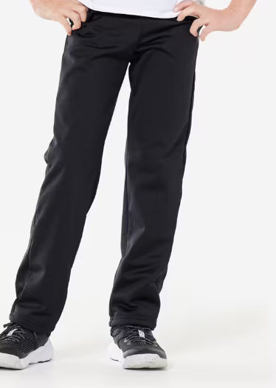Decathlon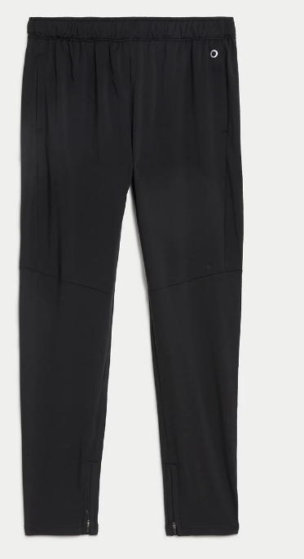M&S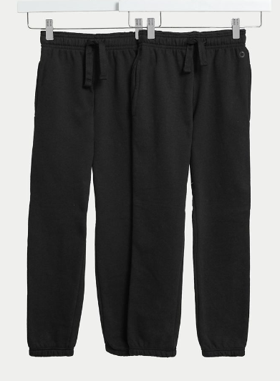 M&S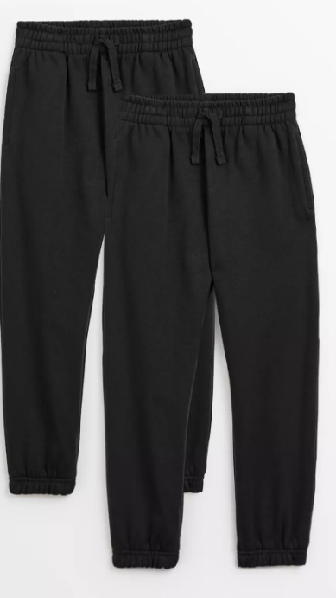 Argos
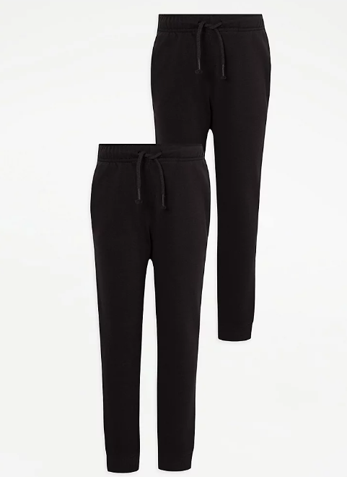ASDA 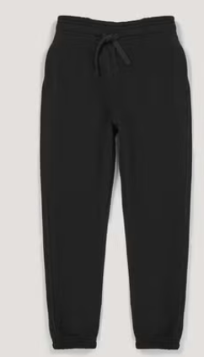Matalan 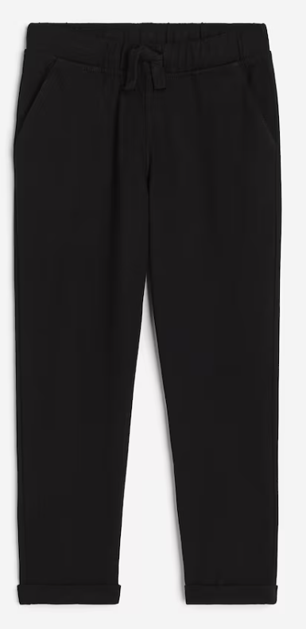H&M 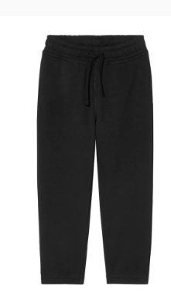Lidl
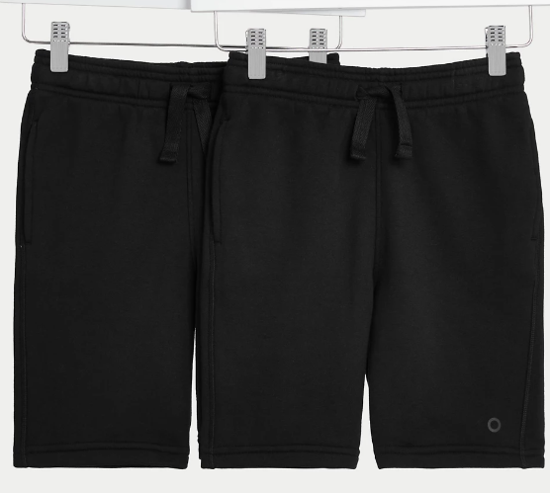M&S 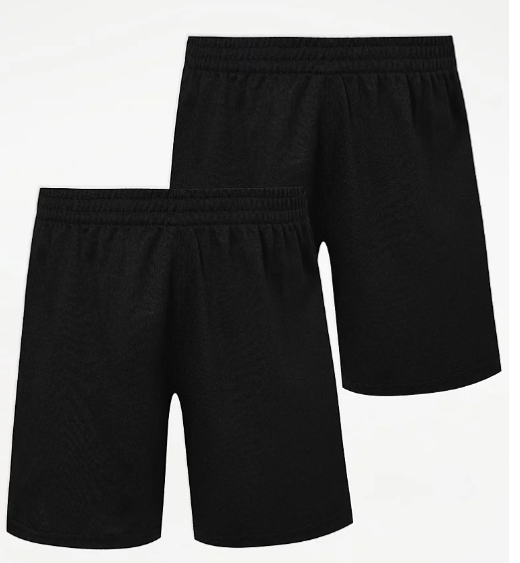ASDA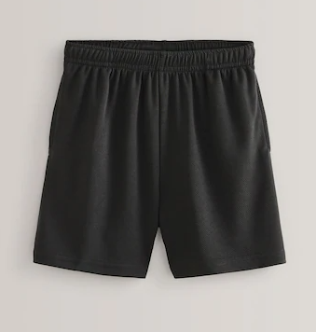 Next
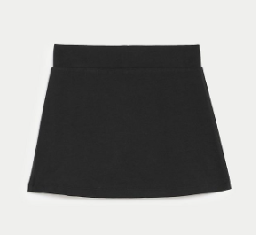M&S 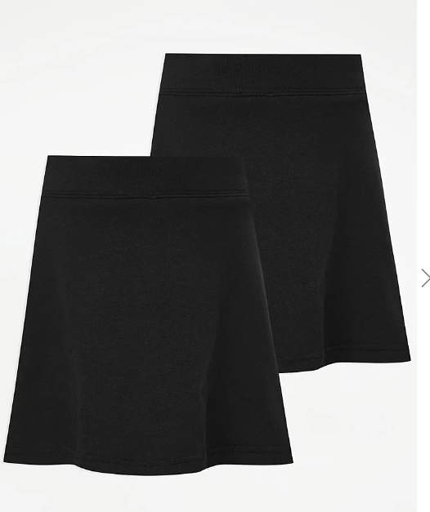ASDA 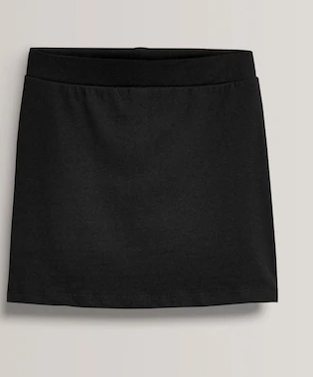Next
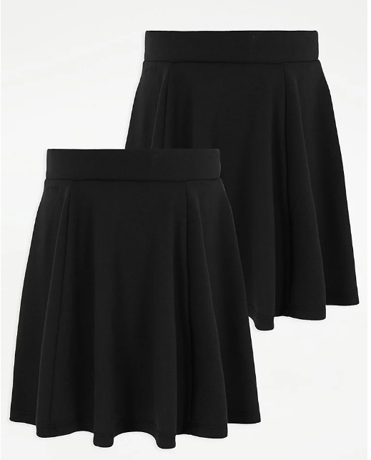 ASDA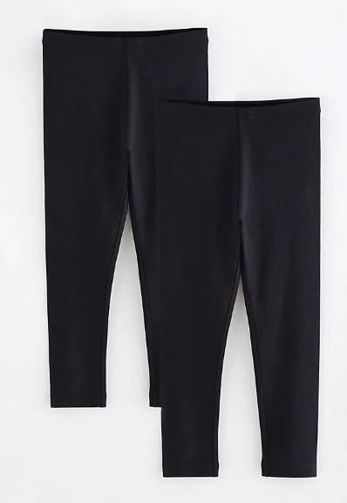ASDA 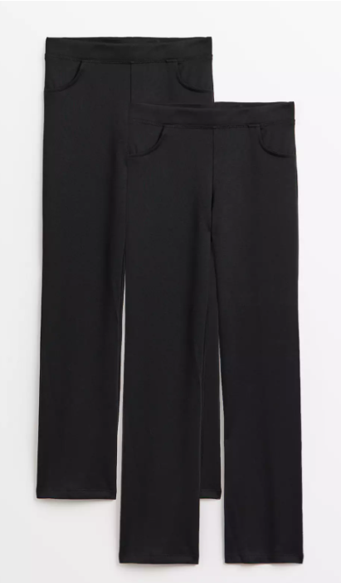 Sainsbury’s 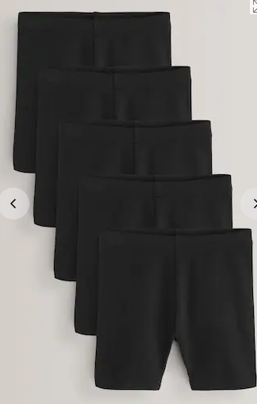 Next

Shoes should be black trainers:
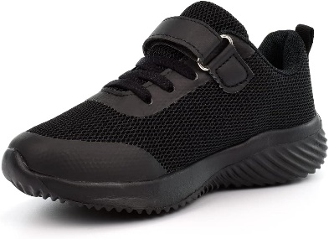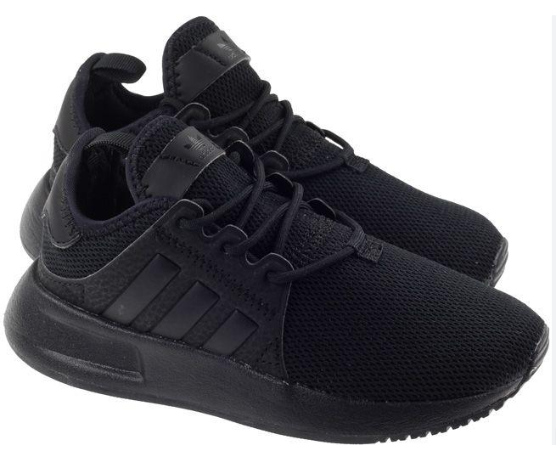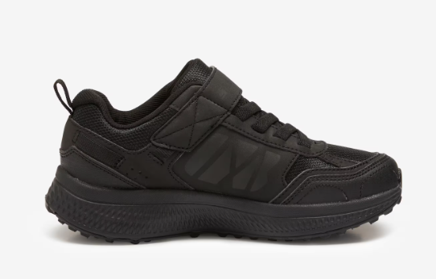
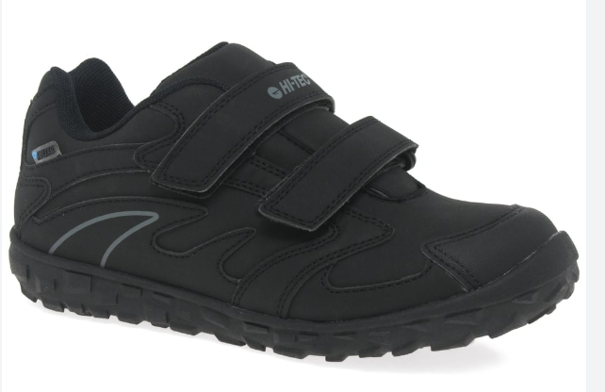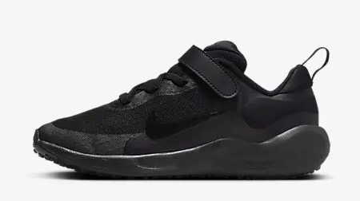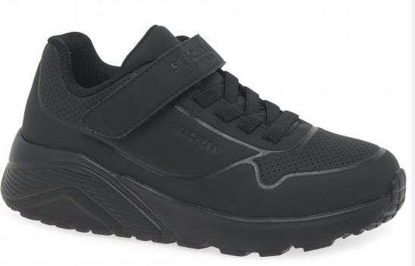
White Polo shirts and Royal Blue Jumpers may be generic:
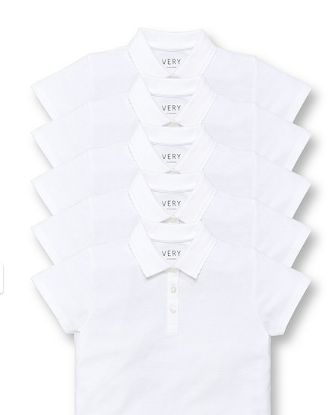Littlewoods 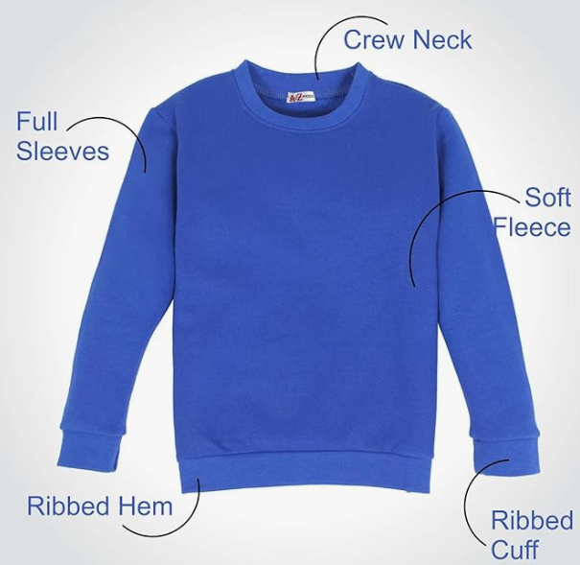Amazon
Alternatively, these are the School Uniform Suppliers for Jumpers and Polo Shirts with school badges.
https://www.schooltrends.co.uk/uniform/KennetValleyCEPrimarySchoolSN84EL
https://www.galileoclothing.co.uk/
https://myclothing.com/collections/kennet-valley-church-of-england-aided-primary-school-20815

